Hi Sumit,

As discussed here is the Wish List for our Dashboard Development plan. Thank you again for finding time tonight to discuss re Dash.

1. Would like to have below as the header, we can clean this up in a better way.

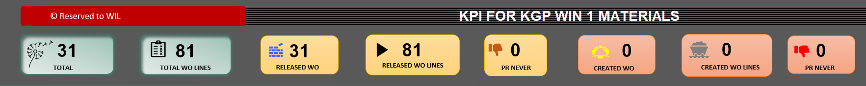

1. PO Delivery Status with After TA, During TA, 2 Wks Before TA, 2 Wks After TA, Any PO arriving a month before

Should have text as On Time.

1. Add Slicers to have an interactive Dash
2. Add the new formula that I gave you as new Supply Status chart
3. Can the Critical WO be included in the PO Delivery status drop down.
4. Key Turnaround Dates tile
5. Can we have all the PO, VENDOR & PO Item auto populated for SP12 Items in “SUPPLY PROCESS” Tab.
6. Can we also have BH report auto populated as well with unique key.
7. Can we have Reservation in the Dash to capture materials with prior demand.

Please REMOVE Below from the excel Dashboard.

1. Remove Material Analysis Tile,
2. Remove orchestration issue chart.

Thank you.